How to Create DLL and use from C# source:

- Make sure you have C:\Windows\Microsoft.NET\Framework\v3.5 (or similar version) added to your system path variables.

- Open command line interface and navigate to the directory that contains the source code.

- Type in the following and press Enter:
“csc /target:library /optimize /nowarn:1591 /out:HapticDriver.DLL /doc:HapticDriver.xml *.cs”

You can also use run the “makeDLL.BAT” file to automatically execute the above sequence. You should see an output similar to below with all the same compiler warnings that you would normally expect.

c:\Courses\haptic-research-group\wireless_haptic_belt\code\C# DLL>makeDLL.BAT

c:\Courses\haptic-research-group\wireless_haptic_belt\code\C# DLL\source>csc /ta
rget:library /optimize /nowarn:1591 /out:HapticDriver.DLL /doc:HapticDriver.xml
*.cs
Microsoft (R) Visual C# 2008 Compiler version 3.5.30729.1
for Microsoft (R) .NET Framework version 3.5
Copyright (C) Microsoft Corporation. All rights reserved.

c:\Courses\haptic-research-group\wireless_haptic_belt\code\C# DLL\source>CD..

c:\Courses\haptic-research-group\wireless_haptic_belt\code\C# DLL>

- Verify that the HapticDriver.DLL and HapticDriver.XML files are present.

:
c:\Courses\haptic-research-group\wireless_haptic_belt\code\C# DLL\source>dir
Volume in drive C is ACER
Volume Serial Number is 1C9E-F662

Directory of c:\Courses\haptic-research-group\wireless_haptic_belt\code\C# DLL\
source

11/10/2009 10:48 PM <DIR> .
11/10/2009 10:48 PM <DIR> ..
10/25/2009 11:49 PM 1,878 Buffer.cs
11/10/2009 04:46 PM 11,105 Constants.cs
11/09/2009 01:45 PM 17,254 ConversionUtility.cs
11/10/2009 08:57 PM 26,261 HapticDriver.cs
11/10/2009 10:48 PM 40,960 HapticDriver.DLL
11/10/2009 10:48 PM 20,180 HapticDriver.xml
11/10/2009 02:01 PM 8,072 Magnitude.cs
09/20/2009 09:28 PM 603 MutexLock.cs
11/10/2009 02:01 PM 10,292 Rhythm.cs
11/10/2009 08:54 PM 14,048 SerialPortManager.cs
10 File(s) 150,653 bytes
2 Dir(s) 18,307,710,976 bytes free

c:\Courses\haptic-research-group\wireless_haptic_belt\code\C# DLL\source>

How to use a DLL and its XML documentation in a Visual Studio 2008 C# project:

- To use the DLL in your Visual Studio project, copy both HapticDriver.DLL and HapticDriver.XML files to the project directory. The XML file contains the reference documentation for all publically accessible methods, variables, etc.

- In Visual Studio 2008, right-click on your project’s References -> Add Reference:

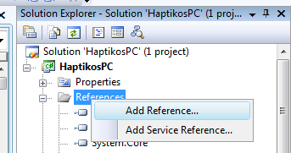

- Click on the Browse tab and select the DLL file you just created.

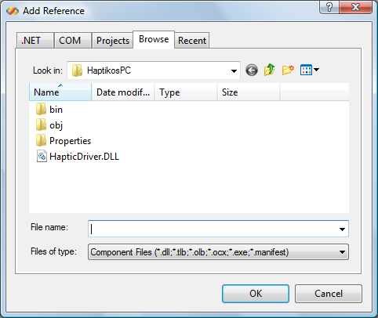

You do not need to do this step for the DLL’s associated XML file as long as they have the same name and reside in the same directory.

- You can now include references to this DLL by normal methods:

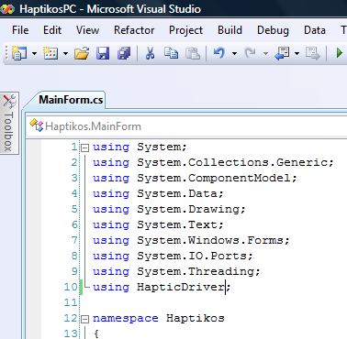

For more resources on C# Compiler Options see the webpages:
http://msdn.microsoft.com/en-us/library/78f4aasd.aspx

OR

http://msdn.microsoft.com/en-us/library/6s2x2bzy.aspx

